StudentHub — Database Design & PHP MySQL Integration

1. Summary of Changes
The following changes were made to add MySQL database support to the StudentHub project:
File | Status | Description
database/studenthub.sql | NEW | Complete MySQL schema with 3 tables (students, events, registrations), foreign keys, constraints, and 5 sample events.
php/db_connect.php | NEW | PHP database connection file using MySQLi with UTF-8 charset support.
php/process_registration.php | MODIFIED | Updated to save student data to MySQL using prepared statements (SQL injection safe). JSON/CSV retained as backup.

2. Entity-Relationship (ER) Diagram
The database consists of three related tables with a many-to-many relationship between students and events, linked through the registrations table.
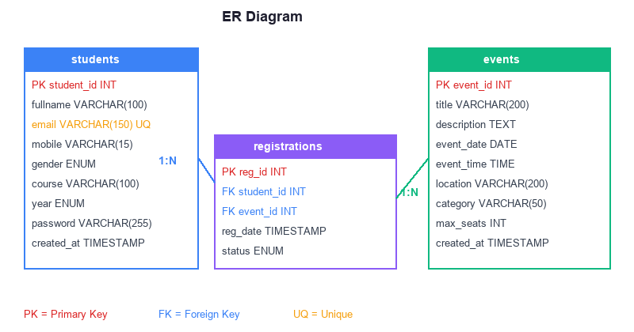

3. Database Schema (studenthub.sql)
This SQL file creates the database and all three tables with proper constraints.

Table: students
Column | Data Type | Constraints
student_id | INT | PRIMARY KEY, AUTO_INCREMENT
fullname | VARCHAR(100) | NOT NULL
email | VARCHAR(150) | NOT NULL, UNIQUE
mobile | VARCHAR(15) | NOT NULL
gender | ENUM | Male / Female / Other
course | VARCHAR(100) | NOT NULL
year | ENUM | 1st-4th Year
password | VARCHAR(255) | Hashed with bcrypt
created_at | TIMESTAMP | DEFAULT CURRENT_TIMESTAMP

Table: events
Column | Data Type | Constraints
event_id | INT | PRIMARY KEY, AUTO_INCREMENT
title | VARCHAR(200) | NOT NULL
description | TEXT | Event details
event_date | DATE | NOT NULL
event_time | TIME | NOT NULL
location | VARCHAR(200) | NOT NULL
category | VARCHAR(50) | Default: General
max_seats | INT | Default: 100
created_at | TIMESTAMP | DEFAULT CURRENT_TIMESTAMP

Table: registrations
Column | Data Type | Constraints
reg_id | INT | PRIMARY KEY, AUTO_INCREMENT
student_id | INT | FOREIGN KEY → students
event_id | INT | FOREIGN KEY → events
reg_date | TIMESTAMP | DEFAULT CURRENT_TIMESTAMP
status | ENUM | Registered / Attended / Cancelled

Output Screenshot — SQL Schema Code
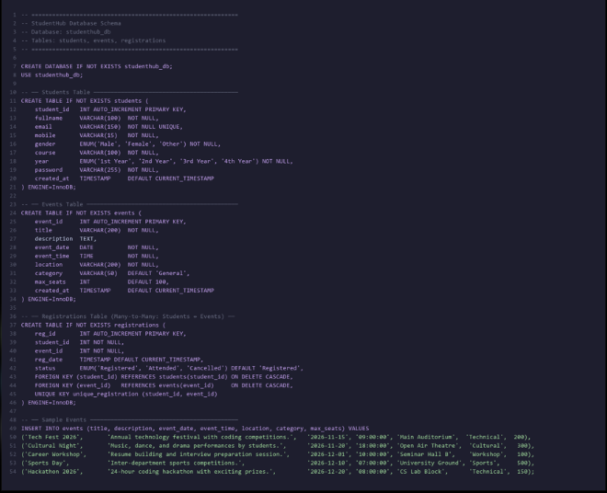

4. Database Connection (db_connect.php)
This file establishes a MySQLi connection to the studenthub_db database. It uses define() constants for easy configuration and sets UTF-8 charset.
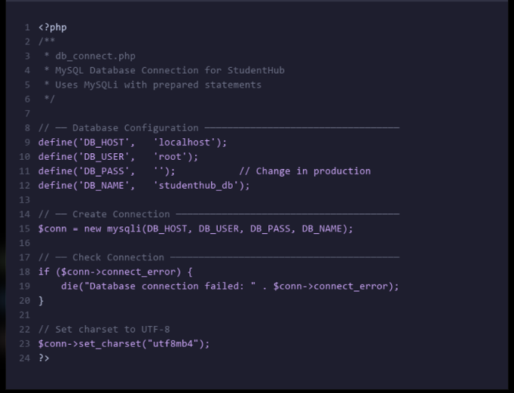

5. Updated Registration (process_registration.php)
The registration PHP file was updated to:
- Include db_connect.php for MySQL connection
- Use prepared statements (bind_param) to prevent SQL injection
- Insert student data into MySQL students table
- Handle duplicate email via MySQL UNIQUE constraint (errno 1062)
- Retrieve auto-generated student_id via insert_id
- Keep JSON and CSV as backup storage
- Close database connection after operation

Output Screenshot — MySQL Insert Code
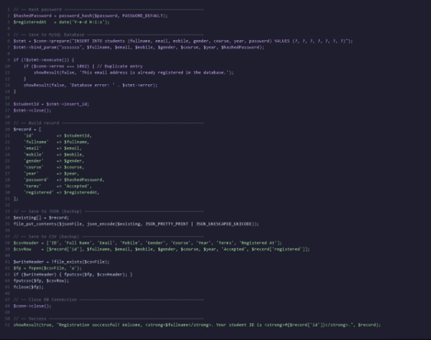

6. Setup Instructions
Step 1: Install XAMPP and start Apache + MySQL services.
Step 2: Open phpMyAdmin (http://localhost/phpmyadmin).
Step 3: Import database/studenthub.sql to create the database and tables.
Step 4: Update credentials in php/db_connect.php if not using default root.
Step 5: Access the registration form and test student registration.

7. Project File Structure
student portalhub 07/
├── database/
│ └── studenthub.sql ← NEW: MySQL schema
├── php/
│ ├── db_connect.php ← NEW: Database connection
│ ├── process_registration.php ← MODIFIED: MySQL support
│ └── process_contact.php
├── data/
│ ├── events.json
│ ├── students.json
│ └── registrations.json (backup)
├── pages/
│ ├── register.html
│ ├── login.html
│ ├── events.html
│ └── ... (other pages)
├── css/style.css
├── js/main.js
└── index.html

